Exercise-1

1. Is your browser running HTTP version 1.0 or 1.1? What version of HTTP is the
server running?

Ans.
My browser is running HTTP version 1.1.
The server is also running HTTP version 1.1.

2. What languages (if any) does your browser indicate that it can accept to the
server?

Ans.
Accept-Language: en-US,en;q=0.5

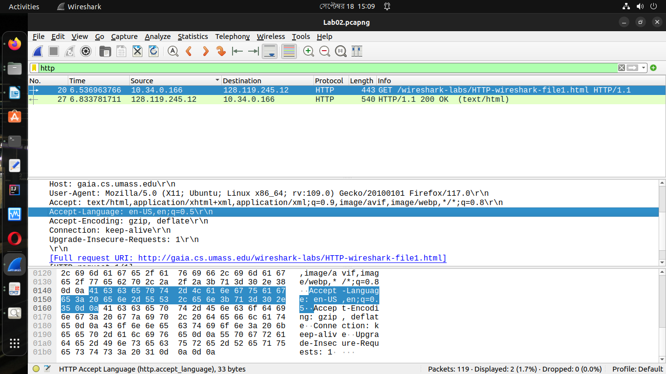
3. What is the IP address of your computer? Of the gaia.cs.umass.edu server?

Ans.
IP address of my computer: 10.34.0.166
IP address of the server : 128.119.245.12

4. What is the status code returned from the server to your browser?

Ans.
Status code: 200 OK

5. When was the HTML file that you are retrieving last modified at the server?

Ans.
Last-Modified: Mon, 18 Sep 2023 05:59:02 GMT

6. How many bytes of content are being returned to your browser?

Ans.
Content-Length: 128 bytes

7. By inspecting the raw data in the packet content window, do you see any headers
within the data that are not displayed in the packet-listing window? If so, name One.

Ans.
No, I do not see any different headings between the two windows.

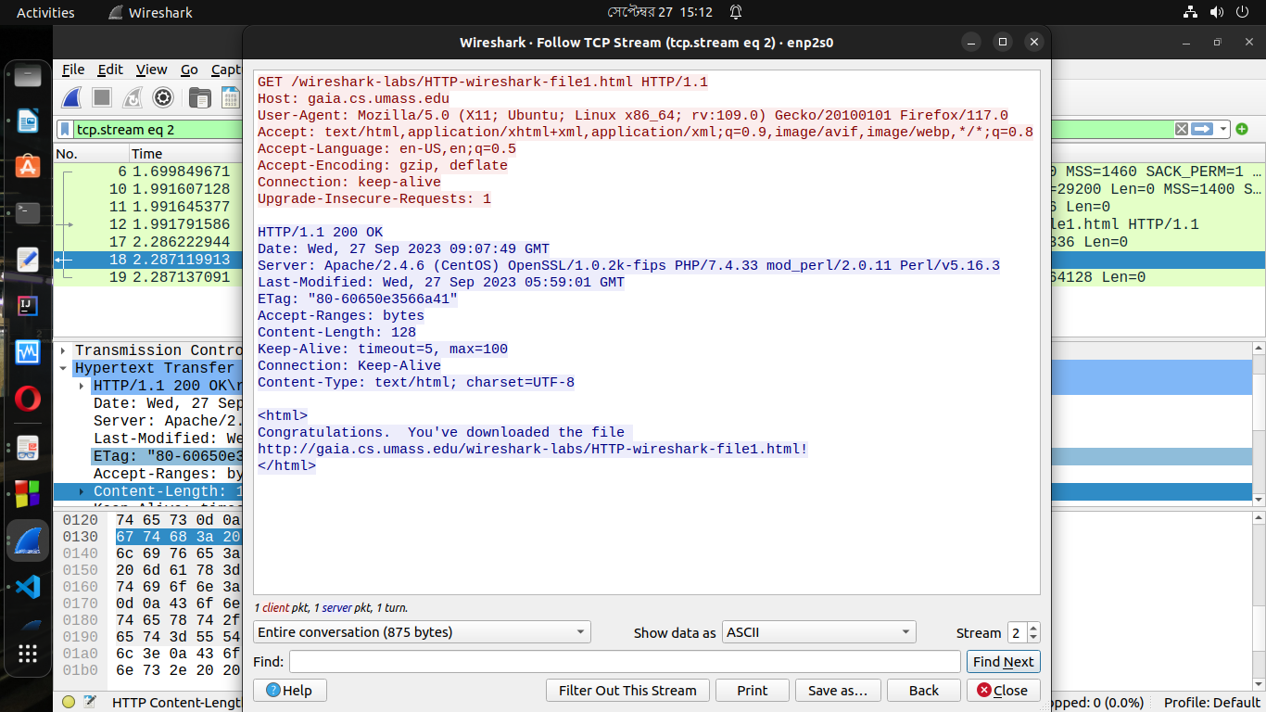

Exercise-2

8. Inspect the contents of the first HTTP GET request from your browser to the
server. Do you see an “IF-MODIFIED-SINCE” line in the HTTP GET?

Ans.
No, there is no IF-MODIFIED-SINCE line in the GET message.

9. Inspect the contents of the server response. Did the server explicitly return the
contents of the file? How can you tell?

Ans.
Yes, the server explicitly returns the contents of the file. In “Line-Based Text Data” section shows what the server sent back to my browser which is specifically what the website showed when I brought it up on my browser.
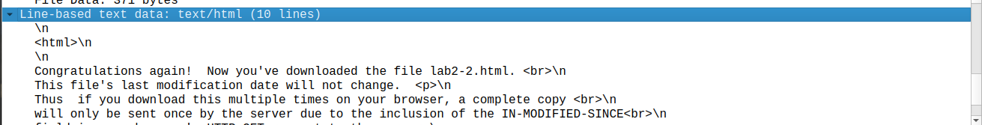

10. Now inspect the contents of the second HTTP GET request from your browser to
the server. Do you see an “IF-MODIFIED-SINCE:” line in the HTTP GET? If
so, what information follows the “IF-MODIFIED-SINCE:” header?

Ans.
Yes, in the second HTTP message an IF-MODIFIED-SINCE line is included. The information that follows is the date and time that I last.

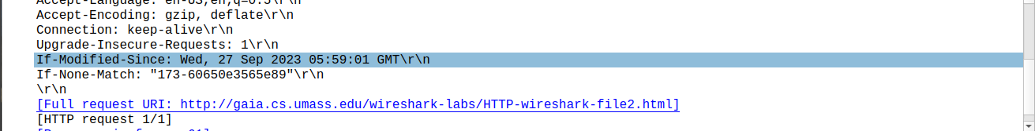
11. What is the HTTP status code and phrase returned from the server in response to
this second HTTP GET? Did the server explicitly return the contents of the file?
Explain.

Ans.
The HTTP status code is “304 Not Modified”.
The server did not return the contents of the file because the browser simply retrieved the contents from its cache. If the file modified since it was last accessed, it would have returned the contents of the file, else it simply told my browser to retrieve the old file from its cached memory.
Exercise-3
12. How many HTTP GET request messages did your browser send? Which packet number in the trace contains the GET message for the Bill or Rights?
Ans.
My browser sent one HTTP GET request to the server. The Packet that contained the GET message was packet number 33.

13. Which packet number in the trace contains the status code and phrase associated with the response to the HTTP GET request?

Ans.
The packet that contains the status code and phrase which the server sent in response to the GET message was packet number 46.

14. What is the status code and phrase in the response?
Ans.
The code and phrase in the response was 200 OK.

15. How many data-containing TCP segments were needed to carry the single HTTP response and the text of the Bill of Rights?
Ans.
The data was sent in four TCP segments to the browser.

Exercise-4
16. How many HTTP GET request messages did your browser send? To which Internet addresses were these GET requests sent?
Ans.
My browser sent three http GET message requests.
- Initial Page address: 128.119.245.12
- Pearson Logo: 128.119.245.12
- Pearson book, 8th Edition: 178.79.137.164

17. Can you tell whether your browser downloaded the two images serially, or whether they were downloaded from the two web sites in parallel? Explain.
Ans.
The browser downloaded the two images serially. Because the first image was requested and sent before the second image was requested by the browser. If they are running in parallel, only one Get will be found.

Exercise-5

18. What is the server’s response (status code and phrase) in response to the initial
HTTP GET message from your browser?

Ans.
Server’s initial response was “401 Unauthorized”.

19. When your browser’s sends the HTTP GET message for the second time, what
new field is included in the HTTP GET message?

Ans.
The new field that is now included is the “Authorization” field. This is included because we sent the server a username and password along with our request stating that we were authorized to receive the page.

